EXPERIMENT - 5
Set 5: Website Analytics

Dataset: Website Traffic
Date | Page Views | Click-through Rate
2023-01-01 | 1500 | 2.3%
2023-01-02 | 1600 | 2.7%
2023-01-03 | 1400 | 2.0%
2023-01-04 | 1650 | 2.4%
2023-01-05 | 1800 | 2.6%

Question 1
Create a line chart to visualize the trend in daily page views over time. Label the axes and title the chart.

R Code
# Set 5 - Q1: Line chart of daily page views
date <- as.Date(c("2023-01-01","2023-01-02","2023-01-03","2023-01-04","2023-01-05"))
page_views <- c(1500, 1600, 1400, 1650, 1800)

plot(date, page_views, type = "o", col = "blue", lwd = 2, pch = 16,
main = "Trend in Daily Page Views",
xlab = "Date", ylab = "Page Views")
grid()

Output
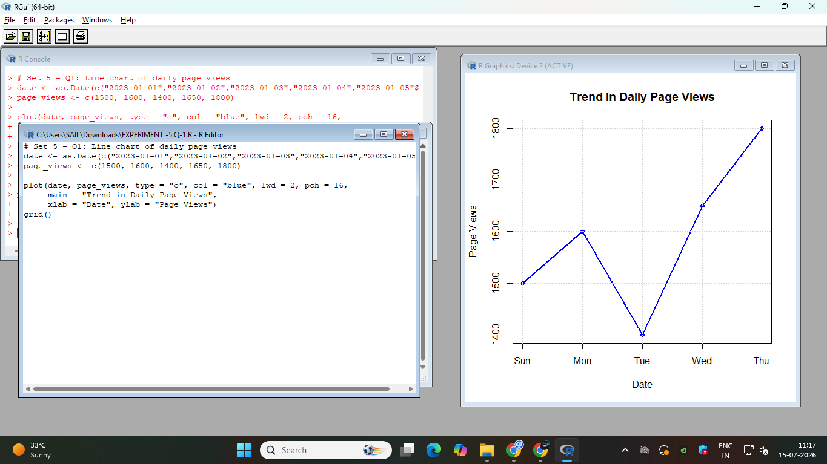

Question 2
Generate a bar chart showing the top N days with the highest click-through rates. Label the chart elements.

R Code
# Set 5 - Q2: Bar chart of top N days by click-through rate
date <- c("2023-01-01","2023-01-02","2023-01-03","2023-01-04","2023-01-05")
ctr <- c(2.3, 2.7, 2.0, 2.4, 2.6) # click-through rate in %

# Choose top N (e.g. top 3 days)
N <- 3
top_idx <- order(ctr, decreasing = TRUE)[1:N]
top_dates <- date[top_idx]
top_ctr <- ctr[top_idx]

barplot(top_ctr, names.arg = top_dates,
main = paste("Top", N, "Days by Click-Through Rate"),
xlab = "Date", ylab = "Click-Through Rate (%)",
col = "tomato", ylim = c(0, max(top_ctr) + 1))

Output
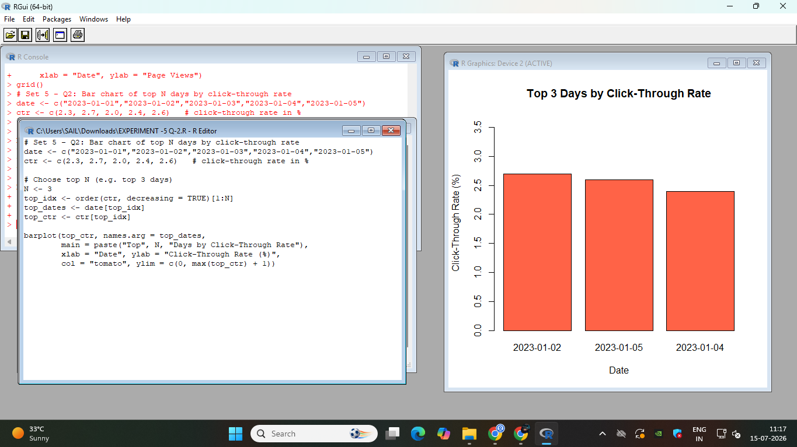

Question 3
Develop a stacked area chart to display the distribution of user interactions (likes, shares, comments) on a website.

R Code
# Set 5 - Q3: Stacked area chart of user interactions (base R, no packages needed)
date <- c("2023-01-01","2023-01-02","2023-01-03","2023-01-04","2023-01-05")
x <- 1:5 # numeric x-axis positions for the dates

likes <- c(120,150,100,170,200)
shares <- c(40,55,35,60,70)
comments <- c(25,30,20,35,45)

# Cumulative sums to stack the areas
comments_top <- comments
shares_top <- comments + shares
likes_top <- comments + shares + likes

plot(x, likes_top, type = "n",
main = "Distribution of User Interactions Over Time",
xlab = "Date", ylab = "Count", xaxt = "n",
ylim = c(0, max(likes_top) + 20))
axis(1, at = x, labels = date)

# Draw stacked polygons from bottom to top
polygon(c(x, rev(x)), c(rep(0, 5), rev(comments_top)), col = "lightgreen", border = NA)
polygon(c(x, rev(x)), c(comments_top, rev(shares_top)), col = "lightblue", border = NA)
polygon(c(x, rev(x)), c(shares_top, rev(likes_top)), col = "lightcoral", border = NA)

legend("topleft", legend = c("Comments", "Shares", "Likes"),
fill = c("lightgreen", "lightblue", "lightcoral"))

Output
